THE POWER OF TECH COMMUNITIES

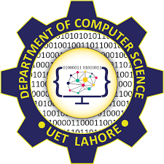

Session 2021-2025

Project Report
Submitted To
Ma’am Faiza Iqbal

Submitted By

Fatima Awais 2021-CS-175
Javaria Iqbal 2021-CS-185
Zoya Naveed 2021-CS-201

Department of Computer Science,
University of Engineering and Technology,
Lahore
Table of Contents
1. Overview 3
1.1 Introduction to the Project 3
1.2 Overview of the Project Components 3
1.3 Learning Outcomes 4
1.4 Why we chose this Project 5
1.5 Tools Employed 5
2. Project Activities 5
2.1 Interview Session 5
2.1.1 Interviewers 5
2.1.2 Interviewee 5
2.1.3 LinkedIn Profiles 6
2.1.4. Questions Asked In the Interview 6
2.2 Seminar 7
2.2.1 Details 7
2.2.2 Key Points 7
2.2.3 QNA Session…………………………………………………………………………………8
3. Outcomes and Impact 9
3.1 What we learnt from this Project 9
3.2 Outcomes …………………………………………………………………………………………...10
3.2 How we met our Objectives 13
4. Conclusion 14
5. References 14

1. OVERVIEW
  - Introduction to the Project:
In the dynamic landscape of contemporary software development, this report delves into the profound impact and inherent power wielded by technology communities. Assigned within the context of the Professional Practice in Software Development (PPSD) course, our investigation includes a series of meticulously conducted interviews and seminars. These endeavors were undertaken to extract valuable insights and perspectives, allowing us to comprehensively explore the essence and significance of tech communities. Defined as collaborative networks of professionals, enthusiasts, and experts, tech communities play a pivotal role in shaping the trajectory of innovation. As we navigate through the results and conclusions derived from our research, this report encapsulates a nuanced understanding of the collaborative synergies that fuel progress within the realm of software development.

  - Overview of the Project Components:
- 1.2.1. Seminar Focus:
    - Knowledge Exchange and Collaboration: One primary focus of the seminar was to delve into how tech communities serve as vibrant hubs for knowledge exchange and collaboration. By bringing together individuals with diverse expertise and experiences, these communities foster an environment conducive to the sharing of insights, best practices, and innovative ideas. The seminar aimed to uncover the mechanisms through which collaborative interactions within these communities propel continuous learning and contribute to the collective growth of its members.
    - Innovation Ecosystems and Industry Impact: Another key point of emphasis was the examination of tech communities as catalysts for fostering innovation ecosystems with tangible impacts on the industry. The seminar delved into real-world examples to illustrate how these communities drive technological advancements, influence industry trends, and contribute to the evolution of best practices. By exploring the link between tech communities and industry impact, the seminar sought to provide a deeper understanding of the broader implications of community-driven innovation in the field of software development.

- 1.2.2. Strategic Advertisement:
    - Utilization of Various Social Media Platforms for Advertisement.
    - Extended an invitation to a seasoned professional from the tech community to guest speak in the seminar.
- 1.2.3. Collaboration with "UTC(Ultimate Tech Crew)" Society:
    - Partnership and Collaboration with Ultimate Tech Crew.
    - Advertise our seminar and get an audience.
    - Poster uploaded in the official pages of Ultimate Tech Crew.
- 1.2.4. Feedback Management:
    - Implementation of Google Forms for Streamlined Participant Registration.
    - Efficient Data Collection for Seminar Coordination.
- 1.2.5. Expert Interviews:
    - Conducting In-Depth Interviews to Gather Insights.
    - Enriching Seminar Content with Real-World Perspectives.
1.3. Learning Outcomes:
1.3.1. To explore and convey the following concepts
- Overview of the significance of tech communities in the industry.
- Experiences and involvement in tech communities.
- Explore how communities contribute to professional development and skill enhancement.
- Examples of successful tech community initiatives.
- Strategies for initiating and growing tech communities.
- Discuss challenges and solutions in community building.
- Emphasize the role of inclusivity and diversity in tech communities.
- Insight into emerging trends in tech communities.
- Explore potential challenges and opportunities for future community development.
1.4. Why we chose this Project (The objective)
- As ambitious individuals in our twenties navigating the dynamic landscape of the tech industry, we are continually on the lookout for innovative opportunities to showcase and elevate our skills.
- At its core, this initiative is designed to be a source of inspiration and guidance for our junior peers. We want to share our experiences, lessons learned, and insights gained throughout our journey in the tech world. By providing tangible examples of how to navigate challenges, harness opportunities, and continually evolve in this fast-paced industry, we aspire to empower our juniors and peers to embark on their own exciting tech adventures.
1.5. Tools Employed:
- Interview Session
- Seminar
- Educational Survey

• Interview Session
• Seminar
• Educational Survey

2. PROJECT ACTIVITIES

2.1. Interview Session
2.1.1. Interviewers
- Zoya Naveed 2021-CS-201
- Fatima Awais 2021-CS-175
- Javaria Iqbal 2021-CS-185
2.1.2. Interviewee
· Muhammad Abdullah
- GDSC Lead Lahore, MLSA Lahore chapter Co-Lead, own initiative Ultimate tech crew (UTC) co-lead.
- First became a part of MLSA in August 2022.
- In 2023 August became GDSC lead.
- Motivation/inspiration: Fellow mates who were leading different communities/societies.
- LinkedIn helped in explore different programs in Google, Microsoft, and GitHub.
- Own initiative: UTC with a fellow student. The main purpose was to fill the gap between industry and academics to learn about the opportunities. Organize events to grow and learn skills.
2.1.3. LinkedIn Profiles:
linkedin.com/in/muhammadabdullah00
2.1.4. Questions Asked in Interview:
- How do communities contribute to professional development and kill enhancement
• All the technical communities (Google, Microsoft, GitHub) provide their ambassadors with their products and skill them accordingly. Normal students cannot avail of these products easily or without paying.
• Personal Example: currently pursuing cloud computing and I got interest in it through the first event I organized for MLSA in January ’23 about Cloud Computing. I used all of Microsoft‘s products in that event. Microsoft can reward you with credits worth $150.
• Networking and Exposure: Access to people who are currently in the field.
• Personal Example: the summer Internship I got was based on volunteer work and my experience in tech communities.
• Microsoft’s courses and certifications cost around $100 but if you are a part of MLSA you can enroll in Microsoft courses free of cost.
- Strategies for initiating and growing tech communities
• Example: UTC was the first community that covered daily jobs, internships, opportunities in tech communities, and ambassador programs.
• Start with a maximum of 4 to 5 people. The team should have potential, be trustworthy, passionate, dedicated, and have the same goal.
• Identify the departments.
• Create an impact.
- Solutions and challenges in community building
As each university has rules and regulations, everyone has to follow them.
• UTC faced some problems from the university since we didn’t want to limit the community to the university level so we found the solution and made it open at the national level.
2.2 Seminar
2.2.1. Details
- Topic: “The Power of tech communities”
- Day: 3-12-2023
- Time: 7-8PM
- Venue: Microsoft Teams
- Speaker:
- Azka Ahmed: Outreach coordinator at ejad labs/FutureFest. Former Google Developer Student Lead.
LinkedIn: linkedin.com/in/azkaahmad2001
2.2.2. Key Points:
- Know the what, why and how of communities.
- Personal Experience of the speaker.
- How do you grow in communities?
- The benefits of your branding.
- “Your Network is your Networth”.
- Technical Skills and Communities go hand in hand.
- Resume and Portfolio building.
- How to create your own tech community?
- Focus on Diversity.
- The future of Tech Communities.
2.2.3. QNA Session
- “If we are dedicating time to it, would it actually help us in getting jobs?”
Answer: The network established through these communities, these are the people who are working in your goal companies. You can always go ahead and utilize your network in a way that can help you understand the culture of the company, can get you connected to the people who does the recruiting for that company.
- “In communities, we have different people with different tech stack, how do one respond or network with them?”
Answer: Usually for people in their second and third year it is recommended that they explore all the different tech stacks and network with people of different tech stacks as well. The best way for this is to ask them "If you could start all over again, how would you do it?” So networking with different people helps you understand your own path.
- “How can someone with zero tech experience become part of communities like GDSC and MLSA?”
Answer: If you could see with GDSC, even though it's a community and it is a predominantly technical community, there are a lot of non-technical positions as well like creative, marketing, and event management positions. Even if someone knows the technical but doesn't know graphic designing or doesn't know how to market, they can learn it from here. The best thing about communities is that the organizers are usually working in very diverse fields. For example: in GDG Live there's Ghania Munawer she's an architect, in GDG Islamabad Omer Nazeer works in associate marketing. These are all people who are part of the community but don't necessarily have the technical skills. So if you have a goal that this is what you want to do then you can easily be part of a technical community.
- “Incase of domains, what if there are not many people of the same domain in your university?”
Answer: You don't need to keep your network or domain restricted to the university. Let's say you can't go to tech events as such, then in that case you can connect with people on LinkedIn as well. People often complain that I do not get replies back on LinkedIn it’s because you send very vague messages. Make sure you send proper, well-constructed, to the point messages and you will get a reply back.
- “While tech communities offer benefits, they come with challenges as well. What are some of the common challenges faced by tech communities and how are they to be addressed?”
Answer: I think the biggest thing I faced was the fact that as a lead I was a girl and the guys in my university were like "We don't want to work under her". Which was very weird for me because I never looked at it from that perspective, so here, your team building and team delegation comes into play. So leading a tech community you have to realize that you will always have to accustom yourself to the kind of people you are working with. The biggest issue would be getting sponsorships and you kind of have to understand the jest of getting sponsorships.
In addition to that because you are a student you don't have that level of platform access and location access. That's the reason why people go for online events. You always have to try and create a network, usually with people who have connections both in the industry and generally as well like fresh graduates.
3. OUTCOMES AND IMPACT
3.1. What we learnt from this Project?
This project has been instrumental in fostering a comprehensive understanding of the thriving tech communities in Pakistan – unraveling the intricacies of their functioning, the invaluable insights they offer, and the myriad benefits they bestow upon their participants. Our exploration of this topic unfolded through a dedicated seminar and insightful individual interview with prominent figures in these communities.
The seminar provided an enriching platform for delving into the dynamics of tech communities, offering a nuanced perspective on how these communities operate and contribute to the technological landscape in Pakistan. Our esteemed speaker, with a wealth of experience in community building, shared invaluable insights into the collaborative ethos that underpins these groups. The discourse extended beyond the surface, shedding light on the collaborative projects, knowledge-sharing mechanisms, and the palpable enthusiasm that permeates through these communities.
The individual interview session, featuring key figures from diverse tech communities. Through candid conversations, we gained profound insights into the motivations that drive community participation, the tangible benefits experienced by members, and the unique challenges faced in fostering inclusivity and sustained engagement. These conversations not only deepened our understanding of the subject but also provided a human touch to the narrative, bringing forth personal anecdotes and experiences that elucidate the transformative power of these communities.
Moreover, our research was fortified by a comprehensive survey that highlighted the reasons behind individuals' decisions to join or abstain from participating in tech communities. The survey results served as a compass, guiding us through the labyrinth of motivations and reservations that influence community involvement. This empirical data not only bolstered our findings but also provided a broader perspective, capturing sentiments from the general audience and unveiling patterns that contribute to the community.
3.2. Outcomes from survey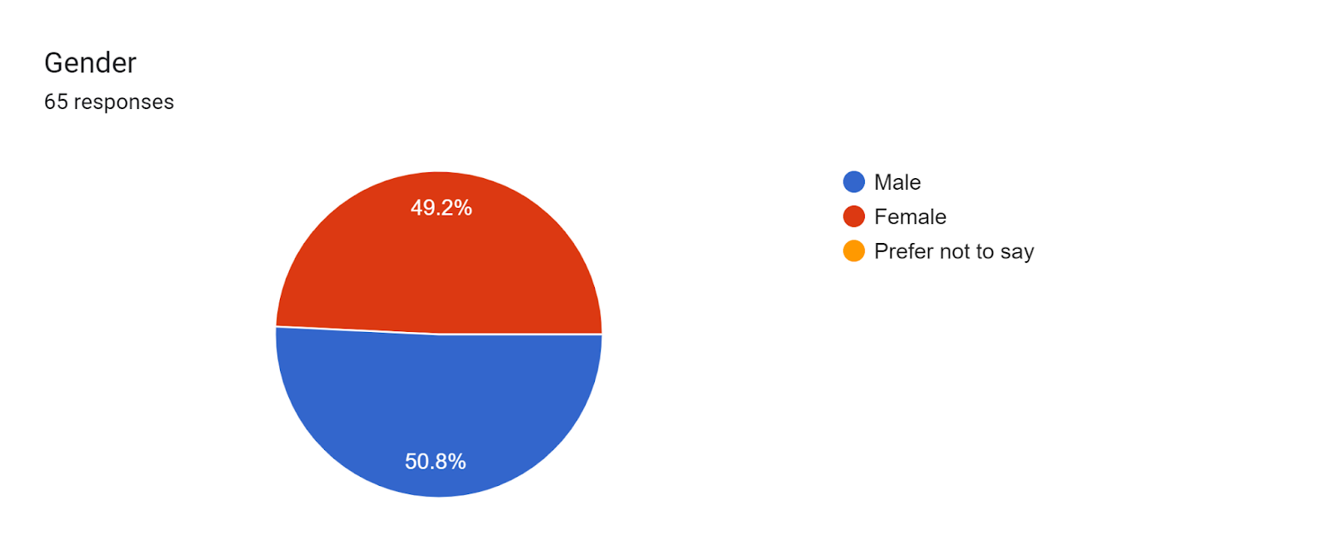
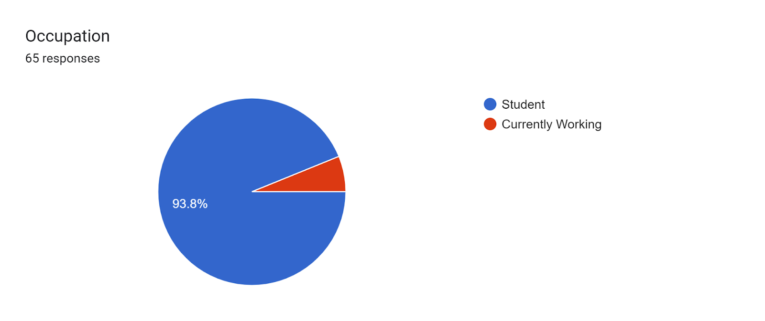
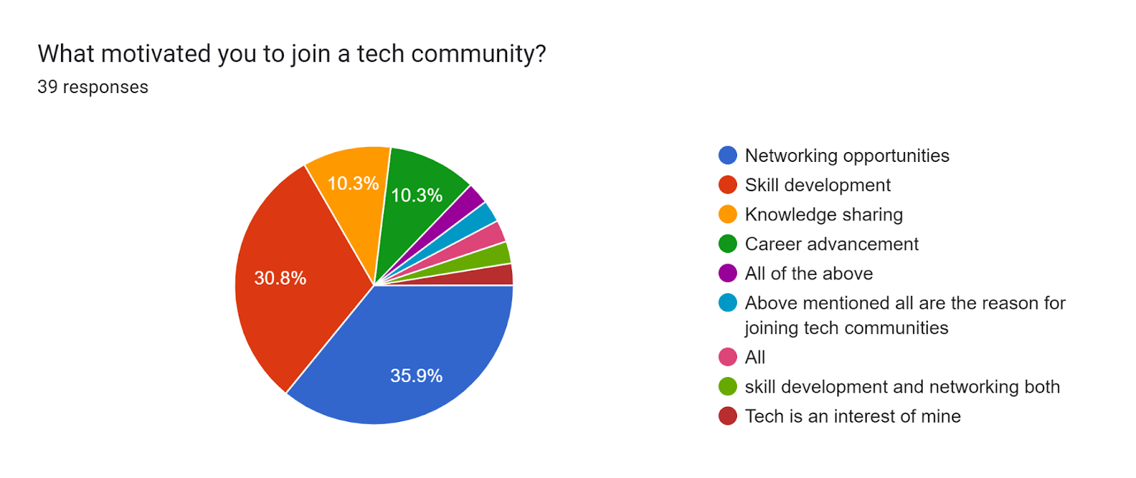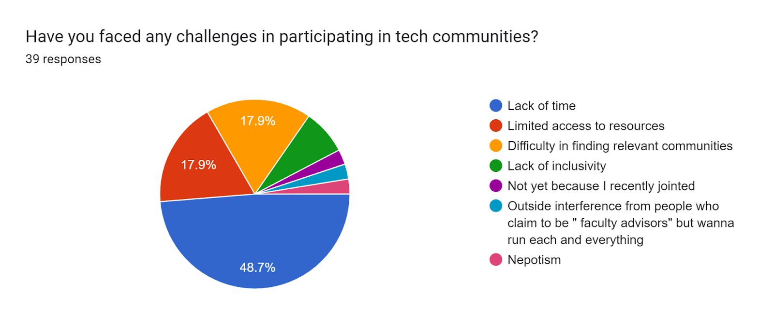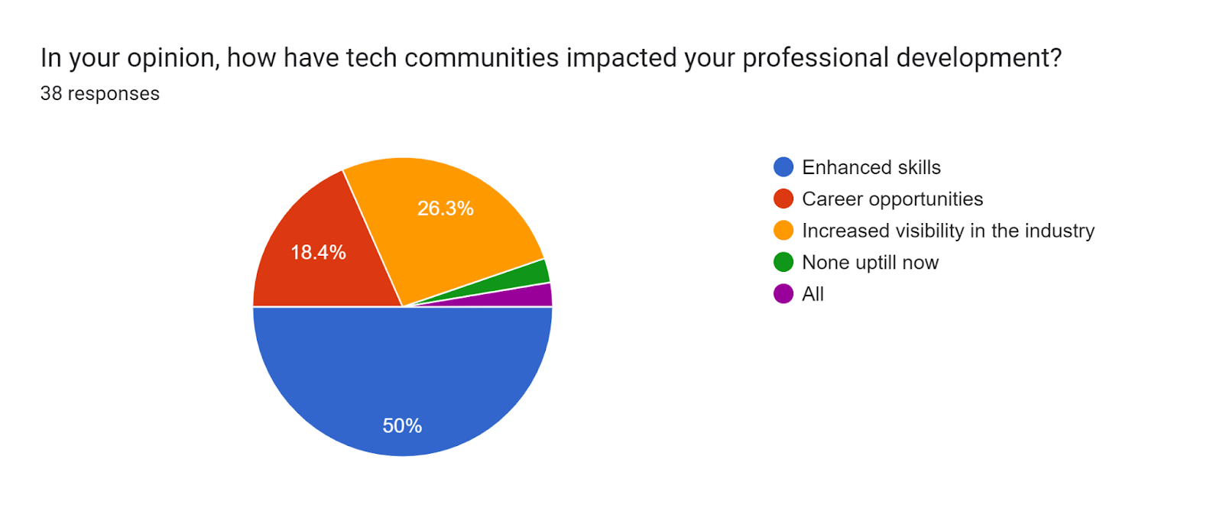

Incase they are not part of Tech communities
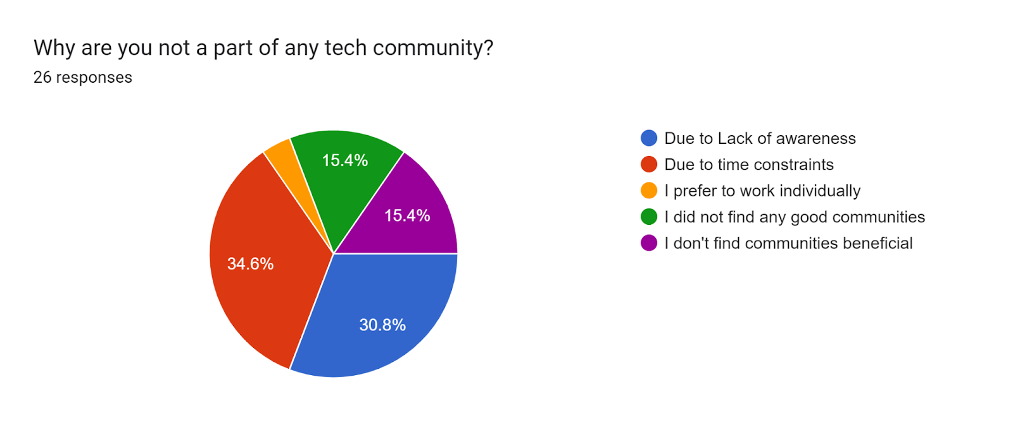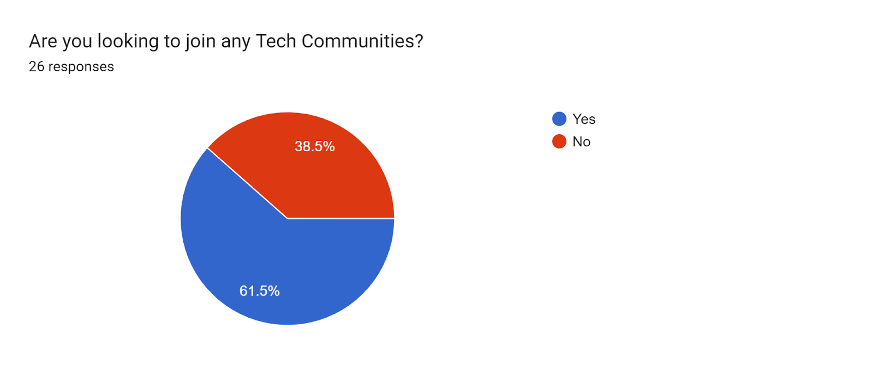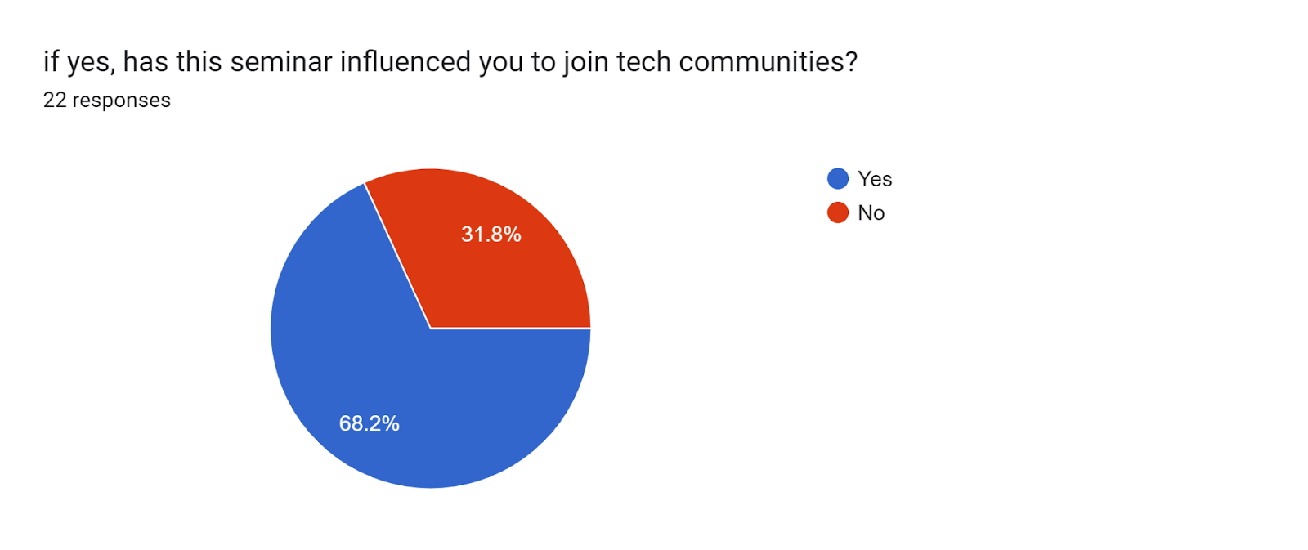
3.3. How we met our objectives?
3.3.1. Seminar on Tech Communities:
Objective: Gain insights into the workings and contributions of tech communities.
Execution: We organized a seminar featuring an accomplished speaker with substantial experience in community building. The speaker shared deep insights into collaborative endeavors, knowledge-sharing mechanisms, and the overall ethos of tech communities in Pakistan.
Outcome: The seminar provided a comprehensive overview, laying the groundwork for understanding the collaborative dynamics and impactful projects within tech communities.
3.3.2. Individual Interview:
Objective: Obtain firsthand perspectives from key figures in tech communities.
Execution: We conducted individual interviews with prominent members of various tech communities. These interviews explored personal experiences, challenges faced, and the tangible benefits derived from community participation.
Outcome: The interviews added a qualitative dimension to our research, offering human stories that illuminated the transformative power of tech communities and provided a deeper understanding of the motivations driving participation.
3.3.3. Comprehensive Survey:
Objective: Understand the reasons behind community participation or non-participation among the general audience.
Execution: We designed and administered a survey to gather quantitative data on the factors influencing individuals' decisions to join or abstain from tech communities. The survey provided empirical evidence to complement the qualitative insights from the seminar and interviews.
Outcome: The survey results served as a valuable tool for encapsulating a broader perspective, identifying patterns, and highlighting trends in community dynamics. This data-driven approach strengthened the overall findings of the project.

4. Conclusion
In summary, our strategic combination of a seminar, individual interviews, and a survey ensured a robust exploration of tech communities. The synthesis of qualitative and quantitative data allowed us to meet our objectives by providing a holistic and nuanced understanding of the subject matter.
5. REFERENCES
- Seminar Poster Image
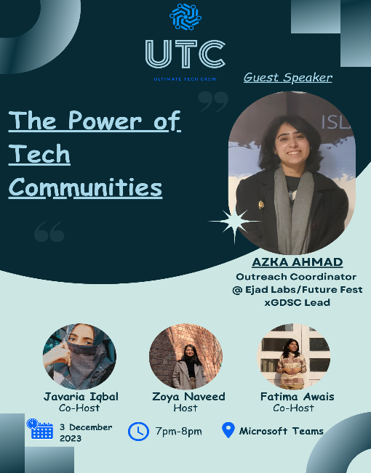

- Seminar Coverage
https://stdntpartners my.sharepoint.com/personal/muhammad_abdullah_studentambassadors_com1/_layouts/15/onedrive.aspx?ga=1&id=%2Fpersonal%2Fmuhammad%5Fabdullah%5Fstudentambassadors%5Fcom1%2FDocuments%2FThe%20Power%20of%20Tech%20Communities
- Seminar Presentation Slides
https://docs.google.com/presentation/d/1b2LyD3GR5PYRhrdJ8uD7TgbabeGv1G9_1Y4xHb1gbjg/edit#slide=id.g2a1b31d6096_0_12
- Interview
Link:
https://stdntpartners-my.sharepoint.com/:v:/g/personal/muhammad_abdullah_studentambassadors_com1/EaABI6R_igNAjrSyOdjwPVcBeOVMIB1t9S95HGmNrVWXew?nav=eyJyZWZlcnJhbEluZm8iOnsicmVmZXJyYWxBcHAiOiJTdHJlYW1XZWJBcHAiLCJyZWZlcnJhbFZpZXciOiJTaGFyZURpYWxvZy1FbWFpbCIsInJlZmVycmFsQXBwUGxhdGZvcm0iOiJXZWIiLCJyZWZlcnJhbE1vZGUiOiJ2aWV3In19&e=A4vrto

